**GIT Remoting**

**Objective:** Pushing source code into GITHUB & collaborate team members.

SECTION-1 (Pushing assignments to remote repository) - Steps to follow:

39. Create a GitHub account if you do not have already.

GitHub Account link: <https://github.com/ShrirangDawande>

40. Login on into github account.

41. Create new public repository ‘freshersbatch-oct16’.

Click on New Repository

In Repository name field type the name of the repository as in this I have typed ‘freshersbatch-jan22’ then check the public after that click on create repository to create a new repository.

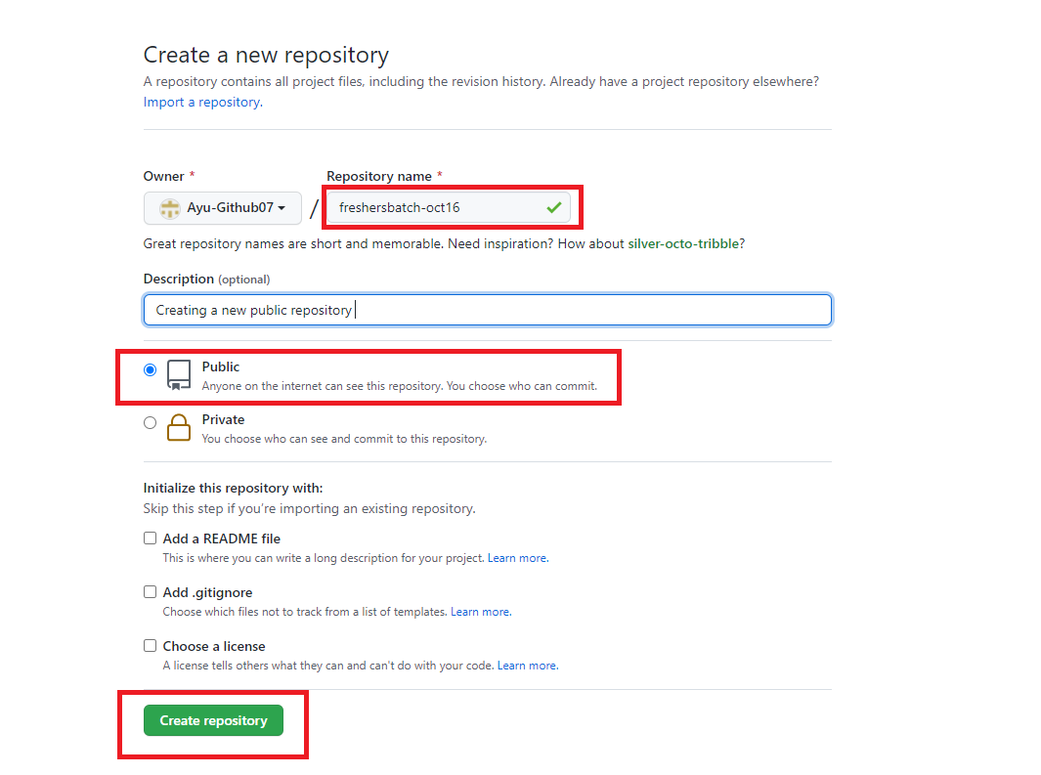

For Pushing files:

Changes in GitHub Repository:

Github Repository link: https://github.com/ShrirangDawande/freshersbatch-jan22